# Introduction

### Purpose and Scope

The purpose of this document is to highlight all the business processes of Cambridge garments pertaining to their manufacturing activities of formal/casual shirts wear. This document covers only the aspects of the business that covers the merchandizing process and all the related activities of formal/casual men shirts:

# Business Description

### Background

Cambridge Garment Industries is one of the leading Importers and Manufacturers of Men's & Children wear woven & knitted quality garments and accessories.

Cambridge brought a fresh perspective to the shirt which had suffered due to faulty collar making and poor tailoring in a traditional “make to order” environment. Cambridge developed expertise in crafting the right collar, which only a garment factory could manage and demonstrated careful fabric selection with fine finishing, producing quality corporate wear that matched the imported shirt experience.

The major imports of Fabric, Garments and Accessories are from different sources of the world like China, Hong Kong, Thailand, India, Turkey, Singapore etc. Product range covers readymade garments like shirts, trousers, knitted garments, sweaters, jackets, men's coats / suits, accessories like neck ties, cuff links, belts, socks and under garments etc.

### Seasons

Cambridge follows a seasonal product calendar identified as A, B C, and D inclusive of several festivals such as Eid, a new theme is developed for each season.

**A =** Winter - starting from November 15th and February 28th, every year.

**B =** Summer - starting from March 1st to July 31st, every year.

**C =** Two Eids - Two eids where apart from seasonal clothing Company has to produce festive clothing’s and traditional Kutras & Shalwar Kameez.

**D =** Sales – where company disposes of its cut range.

### Cambridge Team

Cambridge strength is its human resources, the corporate culture is defined with the clear objectives, which is geared towards high performance and empowers its human resource to unleash their full potential in the below areas:

* Product development
* Merchandising department
* Designing department
* Procurement development
* Marketing department
* Finance / audit and accounts department
* Warehousing department
* HR department

# Process for executing the Formal / Casual Men’s Shirt

### Basics

Cambridge carries an expansive collection of shirts that are divided into brands which cater to different customer segments. All shirts are made from Imported as well as local fabrics:

Following are the brands in which the Men’s formal/casual shirts are available

* **Principal Classic - Formal Shirts**

A true luxury shirt crafted from 100% PIMA cotton. Woven from extra fine cotton yarns to give a high quality appearance, this shirt is an exclusive garment for the discerning wearer. The rich grouping of stripes, checks and a vast variety of diverse set of solid colors.

* **Zero Tolerance - Formal Shirts**

This amazing collection of 100% cotton checks and stripes look, this shirt is ideal for both formal and casual wear.

* **Tomorrow - Formal Shirts**

Available in stripes and checks, made from Chief Value of Cotton (CVC). It is used for both office and casual occasions.

* **Portfolio - Formal Shirts**

This purely businesslike ensemble weaved from 65% cotton and 35% polyester. Available in a portfolio of versatile colors with good weaving comfort, this is a shirt for any occasion.

* **Cambridge Design Studio – Semi-formal Shirts**

Available in stripes and checks, made from CVC and 100% cotton. It is used for both office and casual occasions in smart fit range.

* **After hour – Semi-formal Shirts**

After hour shirts are normally made from linen and polynozel fabrics and it is used for both office and causal occasion and it is made in regular fit.

* **License - Casual Shirts**

License washed shirts are 100% combed cotton, washed in a special process which gives them a distinctive softness.

### Modes of Shirt Making

Cambridge is using different modes of manufacturing / producing shirts which are as follows:

* Local Cut Make & Trim (CMT) with imported/local fabric
* Foreign CMT with imported fabric (e.g. Fabric purchased from China and stitched in Thailand)
* Own factory manufacturing with imported/local fabric
* Imported / local purchase of finished shirt

### Wok Flow Chart for Formal / Casual Shirts

The process of manufacturing / purchasing formal and casual shirt is described in the flow chart as follows:







### Existing software Knowledge Base (KB) procedures and screen shots for the merchandizing sections

**Creation of Accessories Item**: Accessories department create the new accessory item(s) required for a design (except for the generic items). These items can be objects like labels, tags, boxes, buttons, zips, fusing parts etc and most of them are associated with the co-brand. The particular category and/or sub-category is selected and details such as Name, Unit of measurement (UOM), colour, supplier and pricing are entered. The following screenshot depicts the user interface:

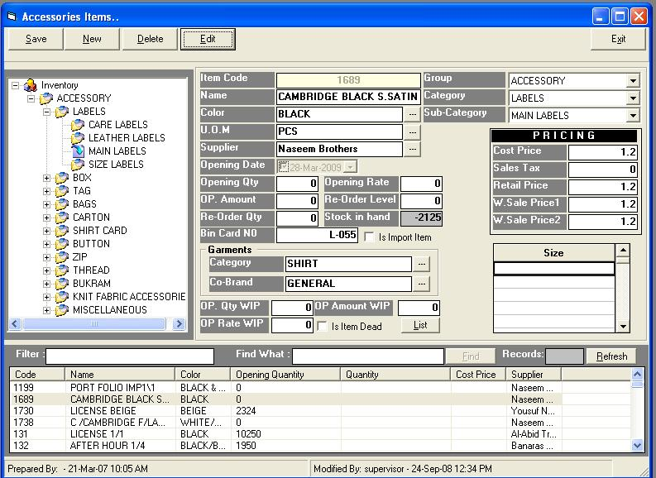

**Creation of Accessories Purchase Order**: Accessories department then proceeds to create the purchase order for the accessory items defined in the above step. The PO may be created for local purchase as well as import. Supplier, payment information, charges, status and item detail are all entered as part of the PO. Once the order is received, the PO is marked as completed. Following is the screenshot for local PO:

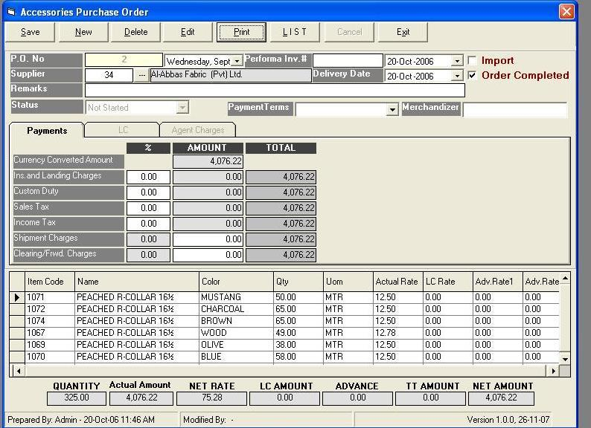

**Creation of Accessories Issuance order**: The issuing of accessories is initiated through an Issuance order which is created by the merchandising department. The accessories issuance order is of two types, with production card or without production card. Information such as date, deadline date, production card and factory are entered. Following is the screenshot for the Issuance order with production card:

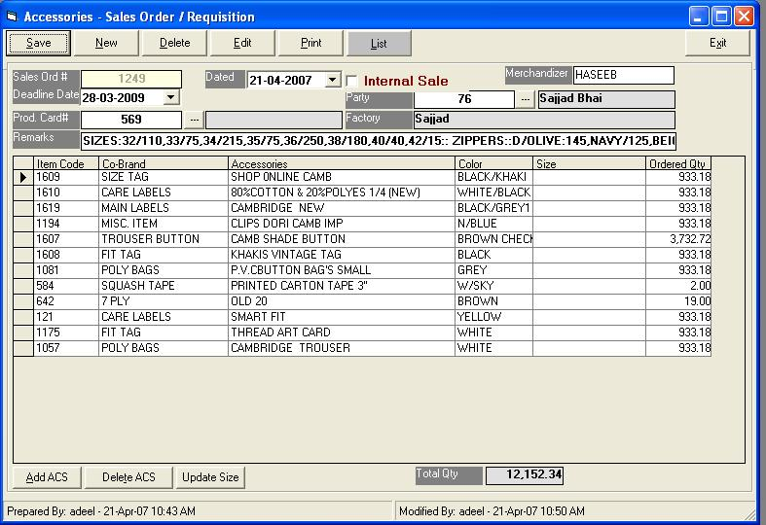

**Creation of Accessories Delivery Challan:** On receiving the Issuance order, the accessories department creates the delivery Challan for the issuing of the accessories to the factory. Following is the screenshot for this:

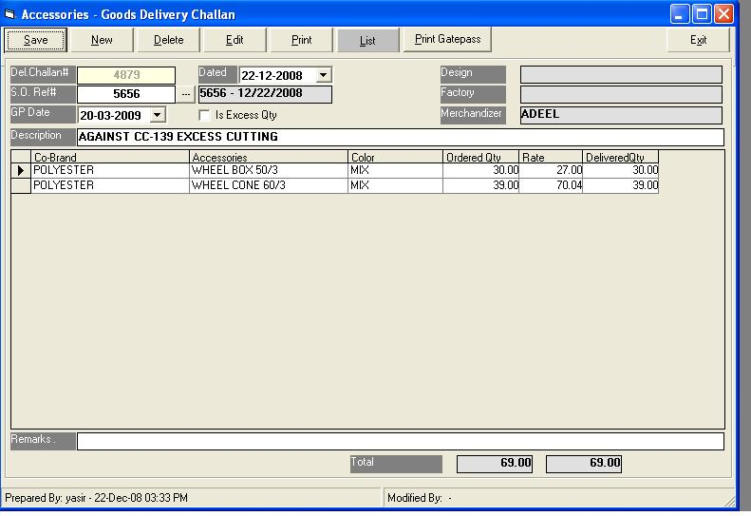

**Creation of Fabric Item**: New fabric item is created on the basis of need or as per requirement. Fabric is associated with co-brand and details such as Name, blend, type, Unit of measurement (UOM), colour, supplier, quantity, rate and pricing are entered. Following is the screenshot for this:

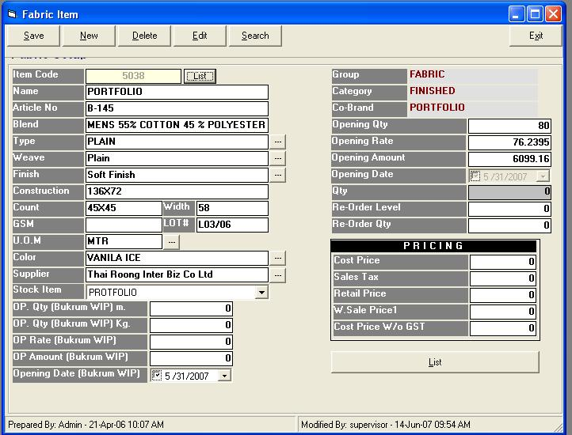

This screen also provides the ease to define multiple colours for a design. Once the user defines a new design and saves it, he can click on new and all the fields except item code and colour are retained on the screen. The user can change the colour here and then save the record and a new item code will be generated. In this way, the user can define multiple colours for a design very quickly.

**Creation of Letter of Credit (LC):** The merchandising department creates a new LC. The following is the screenshot for LC

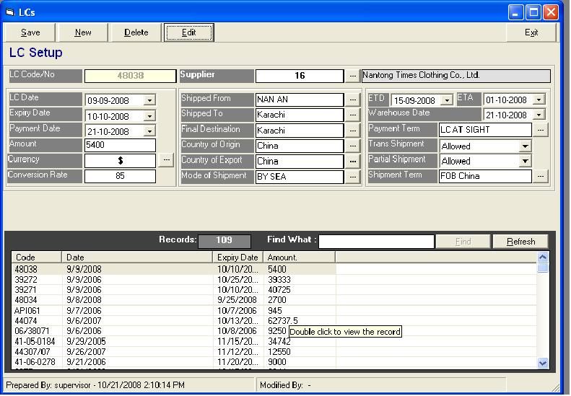

**Creation of Fabric Purchase Order (PO)**: Merchandising department then proceeds to create the purchase order for that particular fabric. Data such as Supplier, payment information, lot # and item detail etc. is entered to create the purchase order. The PO can be for local purchases or import. Following is the screenshot for local PO:

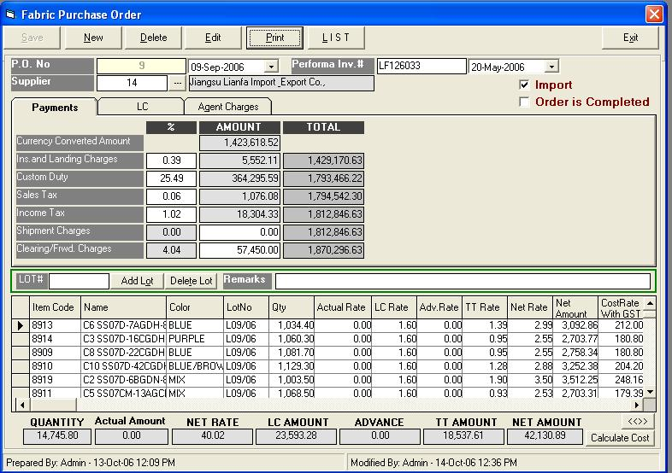

**Designing the Garment**: The merchandising department designs the garment which may be a shirt, trouser, shalwar suit, necktie, sweater etc and the styling information can be different for each category. The design, styling, pricing, fabrics and accessories are described during the garment designing. The screen has four tabs for which data has to be entered: Styling, Colours, Accessories and Pricing. The following are the screenshots for each of these tabs:i. Styling: The style title code, style description for each style title and size set are entered on this tab.

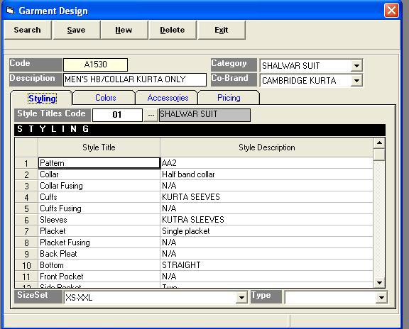

The style titles for some of the main categories are shown in the screenshots below:

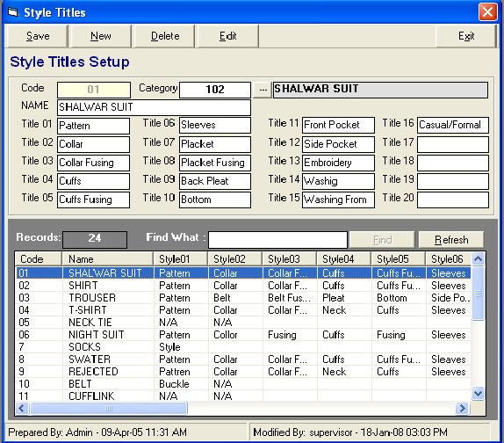

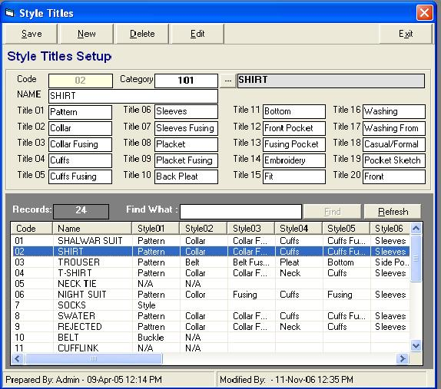

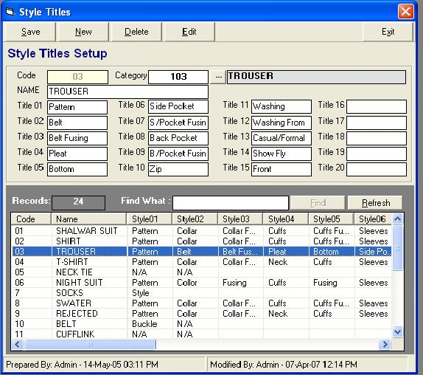

Colours: Different colours for the design are entered here.

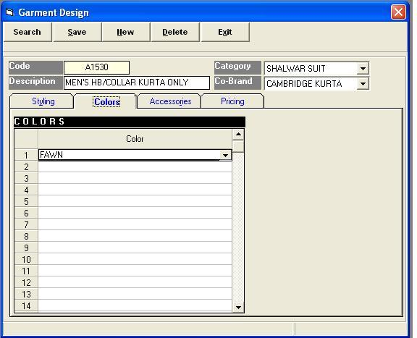

iii. Accessories: The accessory codes and quantities are added on this tab.

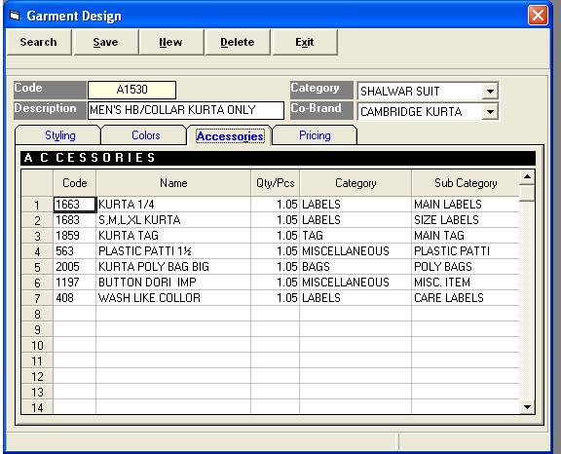

iv. Pricing

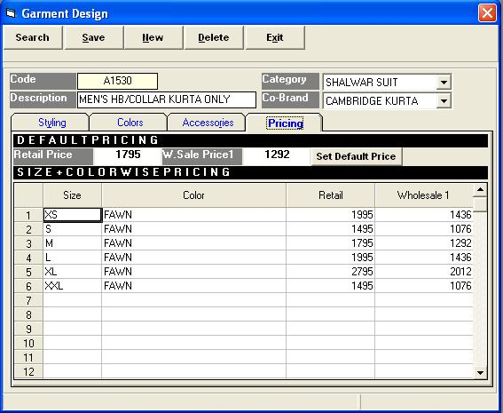

**Creation of Production Card**: The production card is the document which details the complete production of any particular shipment. The merchandising department creates the production card by defining the Design/style, category, co-brand, fabric detail, factory, accessories and production ratio. The following is screenshot for this:

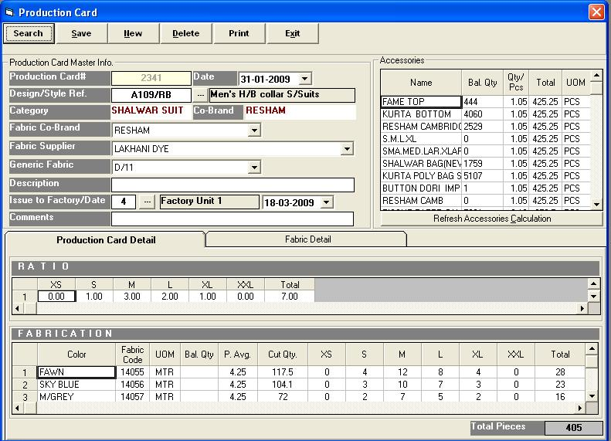

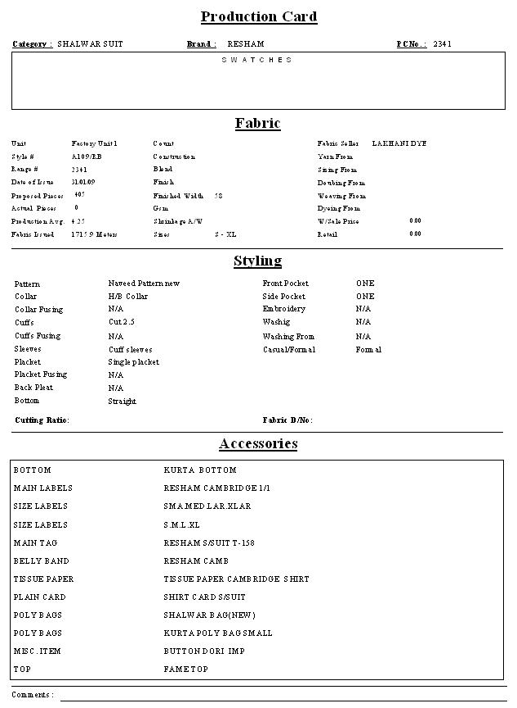

**Creation of Fabric Cutting Range**: The cutting range document determines the ratio and proportion of the fabric that needs to be cut. The merchandising department enters the production card #, design #, factory/unit and description. The fabric and styling information can be looked up through the production card. The following is the screenshot for this:

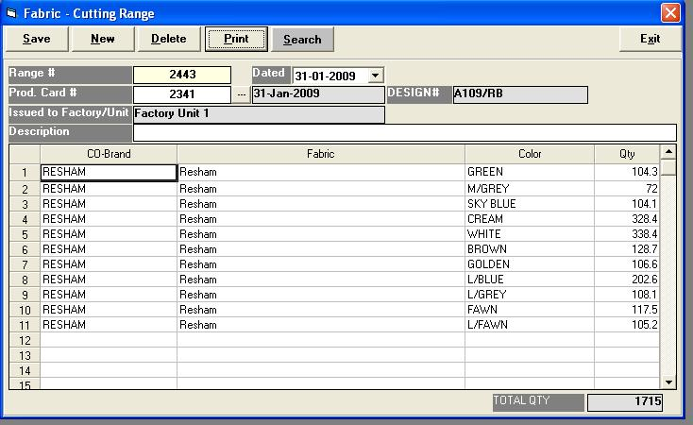

### Fabric Cutting Range printout.JPG

### Fusing parts Management – Basic Workflow

Fusing parts are used in collars, cuffs etc. and are imported or purchased locally. Fusing parts are maintained through two stores: one for rolls and the other for cut fusing parts. The following steps are part of the Fusing parts management phase:

**Creation of Fabric Item for fusing parts**: New fabric item for fusing parts is created by the merchandising department on the basis of requirement. Details such as Name, type, Unit of measurement (UOM), colour, supplier, quantity, rate and pricing are entered. Following is the screenshot for this:

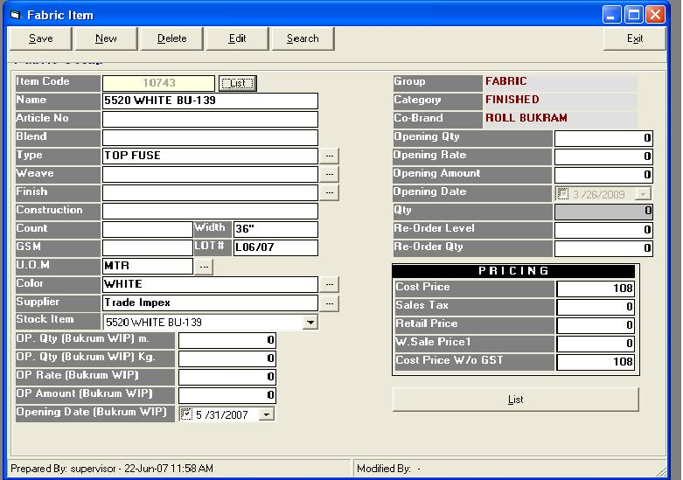

**Creation of Cutting plan and Requisition slip:** The merchandising department first creates the cutting plan which specifies how the fusing parts rolls will be cut. Then the requisition slip is created and sent to the Fusing Parts department to facilitate the issuing of the Fusing Parts rolls.

**Fusing rolls issuing to Cutting department**: On the basis of the cutting plan and the requisition slip, the Fusing Parts rolls are then issued by the Fusing Parts department to the cutting department. The date and item details are entered in this screen. The screenshot for this

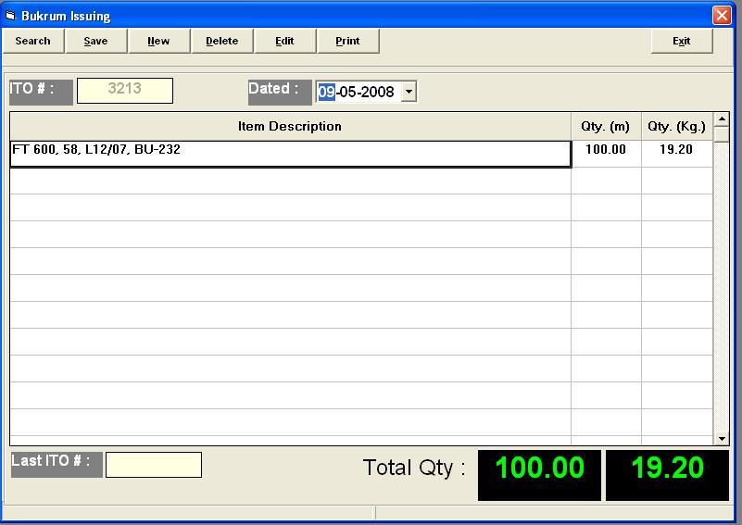

**Fusing Parts Item Production**: Fusing Parts item production is defined by the merchandising department. The Date, fabric item and item details are entered as part of this. The screenshot for this is:

